Yorkshire Association of Change Ringers
Garment Details
Please send orders with cheque payable to “Mrs C H Kirby” to:
Mrs C Kirby, 1 Watford Ave, Norwood Green, Halifax, HX3 8QL
(Tel: 01274 698939 / Email: carolekirby@btinternet.com)
For Electronic Payments please email for details.
Prices correct as of 1st May 2023 but subject to change

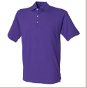
UNISEX PREMIUM POLO SHIRT (RWHB100) £22
XS* 34” S 36” M 38/40” L 42” XL 44/46” 2XL 48” 3XL** 50/52”
Black, Charcoal, Classic Red, Heather Grey, Lilac, Navy, Purple, Royal, Turquoise, White, Bottle Green, Fuchsia

*XS Black, Navy and White only
**3XL Black, Bottle, Classic Red, Heather Grey, Navy, Royal and White only

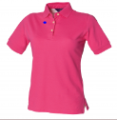
WOMENS PREMIUM POLO SHIRT (RWHB121) £22
S 10 M 12 L 14 XL 16 2XL 18
Black, Navy, White

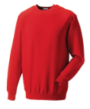
UNISEX CLASSIC SWEATSHIRT (RW7620) £25
XS 34/36" S 36/38" M 38/40" L 40/42" XL 42/44" 2XL 44/46" 3XL* 46/48" 4XL* 48/50"
Black, Bright Red, Classic Red, French Navy, Light Oxford, Bottle Green, Burgundy, Bright Royal, Grey
*Bottle Green, Bright Royal and French Navy only

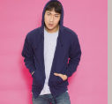
COTTON RICH ZOODIE (Full zip hoodie) (RWJH050) £30
S 36" M 40" L 44" XL 48" 2XL 52" 3XL* 56" 4XL* 60" 5XL* 64"
Arctic White, Ash, Charcoal, Fire Red, Forest Green, French Navy, Hawaiian Blue, Heather Grey, Hot Pink, Jet Black, Kelly Green, New French Navy, Orange Crush, Oxford Navy, Purple, Red Hot Chilli, Royal, Sapphire Blue, Steel Grey, Sun Yellow Bottle Green, Burgundy
* Heather Grey, New French Navy and Black only
Right hand side pocket has small hidden opening for earphone cord feed and hidden ear phone loops

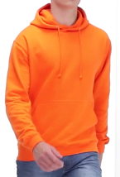
UNISEX HOODIE (RWJH001) £30
XS 34” S 36" M 40" L 44" XL 48" 2XL 52" 3XL* 56" 4XL* 60" 5XL* 64"
Airforce Blue, Alien Green, Apple Green, Arctic White, Ash, Baby Pink, Brick Red, Burnt Orange, Candy Floss Pink, Charcoal, Cranberry, Desert Sand, Fire Red, Forest Green, Gold, Hawaiian Blue, Heather Grey, Hot Chocolate, Hot Pink, Jade, Jet Black, Kelly Green, Lavender, Lime, Lipstick Pink, Magenta Magic, Moondust Grey, Moss, New French Navy, Olive, Orange Crush, Oxford Navy, Peppermint, Pinky Purple, Plum, Purple, Red Hot Chilli, Royal, Sapphire Blue, Sky, Steel Grey, Storm Grey, Sun Yellow, Vanilla Milkshake, Cornflour Blue, Sunset Red, True Violet, Turquoise Surf, Bottle Green, Burgundy, Denim, Sherbert Lemon, Spring Green, Deep Sea Blue, Tropical Blue, Nude, Ultra Violet
* Heather Grey, Jet Black, New French Navy and Oxford Navy only
Double fabric hood with self-coloured cords. Kangaroo pouch pocket with small hidden opening for earphone cord feed.

MICROFLEECE JACKET (RWHB850) £32
S 36 M 38/40 L 42 XL 44/46 2XL 48 3XL* 50/52
Black, Charcoal, Classic Red, Heather Grey, Navy, Purple, Royal
*Black and Navy only

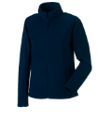
Full zip outdoor fleece (RW8700M) £32
XS 34/36" S 36/38" M 38/40" L 40/42" XL 42/44" 2XL 44/46" 3XL 46/48" 4XL 48/50"
Black, Classic Red. Convoy Grey, French Navy, Bottle Green, Burgundy, Bright Royal

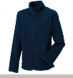
Womens Full Zip Outdoor Fleece (RW8700F) £32
XS 8 S 10 M 12 L 14 XL 16 2XL 18
Black, Classic Red. Convoy Grey, French Navy, Bottle Green, Burgundy, Bright Royal

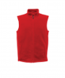
Microfleece Bodywarmer (RWRG185) £24
S 37/38" M 39/40" L 41/42" XL 43/44" 2XL 46/48"
Black, Classic Red, Deep Navy

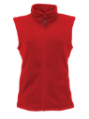
Womens Microfleece Bodywarmer (RWRG186) £24
8 10 12 14 16 18 20
Black, Classic Red, Deep Navy

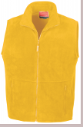
Active fleece bodywarmer (RWRE37A) £26
XS 35" S 38" M 41" L 44" XL 47" 2XL 50" 3XL 53"
Black, Forest Green, Navy, Red, Royal, White, Yellow

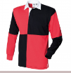
Quartered Rugby Shirt (RWFR02M) £30
S 34/36, M 37/39, L 40/42, XL 43/45, 2XL 46/48
Black/Red, Navy/White

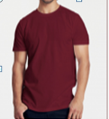
Fairtrade and Organic Mens Fit T-shirt (NT61001) £16
S 48cm, M 51cm, L 54cm, XL 57cm, 2XL60cm, 3XL 63cm, 4XL 67cm, 5XL 71cm
(Sizes are half chest- Actual garment size)
Ash, Black, Bordeaux, Brown, Charcoal, Green, Light Blue, Light Pink, Lime, Navy, Orange, Pink, Purple, Red, Royal Blue, Sand, Sapphire Blue, Sport Grey, Teal, White, Yellow, Military Green, Dark Heather, Bottle Green, Okay Orange, Dusty Purple, Dusty Yellow, Nature, Dusty Mint, Dusty Indigo.
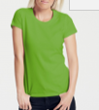
Fairtrade and Organic Ladies Fit T-shirt (NT81001) £16
XS 41cm, S 44cm, M 47cm, L 50cm, XL 53cm, 2XL 56cm
(Sizes are half chest- Actual garment size)
Ash, Black, Bordeaux, Brown, Charcoal, Green, Light Blue, Light Pink, Lime, Navy, Orange, Pink, Purple, Red, Royal Blue, Sand, Sapphire Blue, Sport Grey, Teal, White, Yellow, Military Green, Dark Heather, Bottle Green, Okay Orange, Dusty Purple, Dusty Yellow, Nature, Dusty Mint, Dusty Indigo.

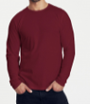
Fairtrade & Organic Mens Long Sleeve T (NT61050) £20
S 48cm, M 51cm, L 54cm, XL 57cm, 2XL60cm, 3XL 63cm
(Sizes are half chest- Actual garment size)
Black, Bordeaux, Green, Navy, Red, Royal, Sapphire Blue, Sport Grey, White, Yellow, Military Green, Dark Heather, Bottle Green

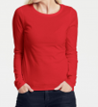
Fairtrade and Organic Ladies L/S T-shirt (NT81050) £20
XS-40cm, S-43cm, M-46cm, L-49cm, XL-52cm, 2XL-55cm
(Sizes are half chest- Actual garment size)
Black, Bordeaux, Green, Navy, Red, Royal, Sapphire Blue, Sport Grey, White, Yellow, Military Green, Dark Heather, Bottle Green

